Kris Development’s

Animation Utilities

# 

A set of editor tools to help you when animating and setting up your characters.

# 1: Armature Bone Retargeting

Select a new **armature / set of bones** to control a given skinned mesh.

## Menu location:

Tools/Kris Development/Animation Utilities/Armature Bone Retargeting

## How to use:

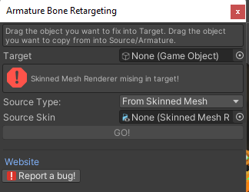Drag in a **Target** that has **Skinned Mesh Renderer** component. The target is the object you want updated or modified.

Select the “Source Type”, meaning the object from which bones will be gathered to put onto the target. That can be either another Skinned Mesh or the root bone transform of an armature. Drag in the reference to the selected source.

Pressing “GO” will run the tool.

If bugs occur, use the “Report a bug!” button, this will send you to the support page on the KrisDevelopment website.

# 2: Armature Bone Drawing

Draws gizmos for the bones of skinned meshes.

## Menu location:

Tools/Kris Development/Animation Utilities/Toggle Bone Drawing

## How to use:

When an **Armature** is selected and Bone Drawing is turned on (on by default), bone gizmos will be drawn for each related bone transform.

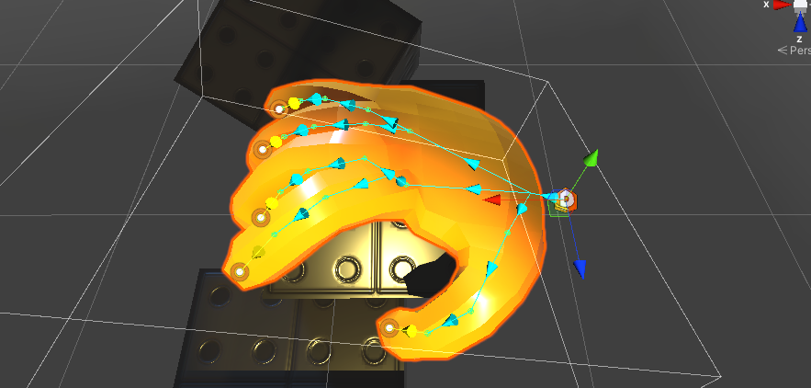

# 3: Skinned Mesh Bones Inspector

Draws the bones related to a selected skinned mesh.

## Menu location:

Tools/Kris Development/Animation Utilities/Skinned Mesh Bones Inspector

## How to use:

Open the tool from the menu and select any Skinned Mesh Renderer. The window will display a list of all currently related bone transforms. You can assign new ones using the Armature Bone Retargeting tool.